The Oath
Proposal for a documentary film

February 23, 1945.

After several days of bloody combat with the Japanese, six marines raised the American flag on Mount Suribachi on the Island of Ivo Jima. Michael Strank, originally from Slovakia, was the leader of this detail.

Thanks to the expressive photograph of Joe Rosenthal, those soldiers became heroes who were revered across the United States.

However fate didn’t allow Strank to live that long. He died in combat a few days later when shrapnel from an artillery shell pierced his heart. He was 25 years old.

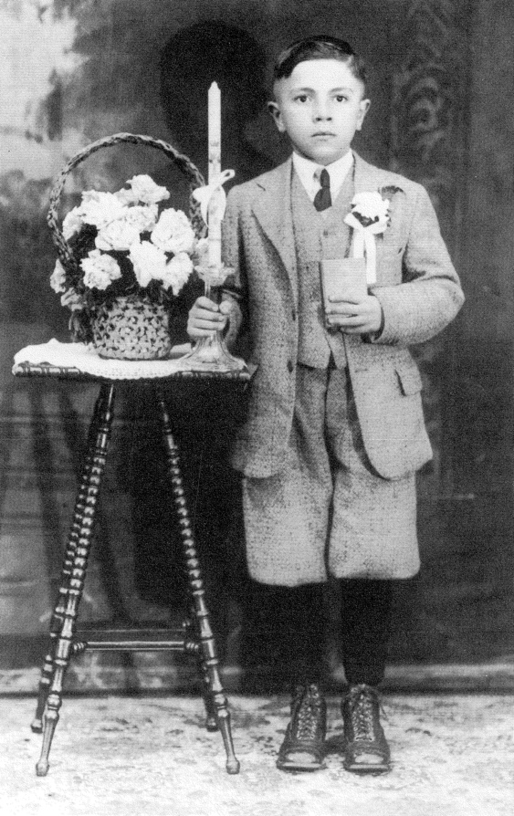
Strank was born into a Greek Catholic family on November 10, 1919 in the Ruthenian village of Jarabina in eastern Slovakia. Poverty drove the family to America in search of work. His father, Vasil, labored in a coal mine in Pennsylvania to support his wife and 5 children.

Thanks to him, Michael could study. He was an excellent student with a photographic memory, a talented musician and baseball player who was feared and respected by his rivals. He had a bright future ahead of him.

The Great Depression destroyed his dreams.

Michael, survived the hardest times of the crisis as a worker on a road construction project in the brutal heat of the Arizona desert. The hard work turned a boy into a disciplined and responsible young man.

When Hitler invaded Czechoslovakia, he enlisted in the Marine Corps because he couldn’t just sit by and watch. He had hoped to return to the land of his birth and fight the Nazis. However, he was sent to Boot Camp in Parris Island for recruit training.

Because of his skills he was assigned to the elite Marine Raiders who were carrying out dangerous surprise strikes, raids under the cover of night behind enemy lines in the South Pacific.

In November 1943, the Marine Raiders landed on the Island of Bougainville.

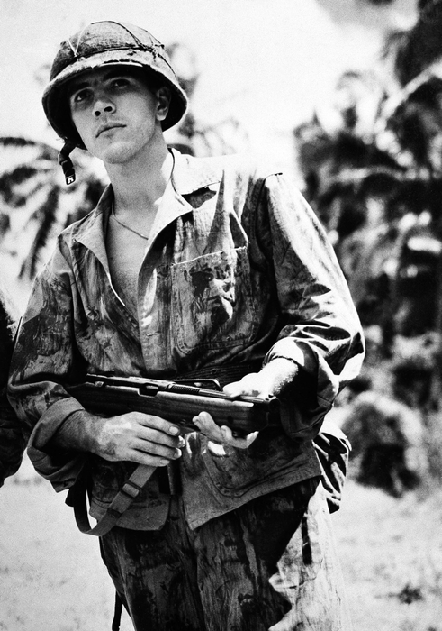
For two months, Strank led his squad in attacks on the Japanese who were almost invisible in the impenetrable jungle. They waded through mud, dodged sniper fire and were shelled with mortar fire and endured poisonous snakes and millions of mosquitos.

Bougainville was a living hell. The Marine Raiders battled under conditions that would have driven ordinary soldiers to the edge of insanity.

Strank contracted malaria and was sent home for a month to recuperate, but he refused to remain in America because he “he couldn’t leave his men because they needed his help.”

Michael also did everything possible to protect his squad during the battle of Ivo Jima where they were constantly under fire from Japanese machine guns and heavy artillery that tore bodies into pieces. It was a massacre.

They remembered how they prayed, “Though I walk through the shadow of the valley of death I will fear no evil…”

It was only a matter of time before that fateful piece of shrapnel flew. It happened at the moment when he was trying to prevent his squad from being surrounded by the Japanese.

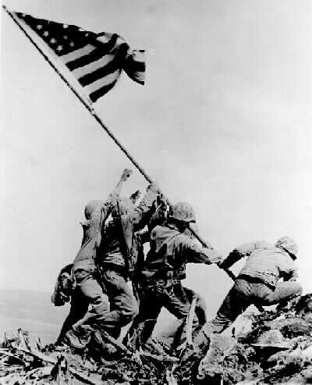
This film will tell the story of the faith of a young man whose skill and energy were dedicated to the battle for freedom and independence and who by sacrificing himself for others fulfilled his destiny. It is also the story of a forgotten hero who remained nothing more than a carved symbol of courage and bravery.

It will be a testimony of Strank’s personal and spiritual maturing, a transformation in all its abundance and complexity and a record of how he confronted his own fear and how his faith in God helped him. A recognition of how he coped with being responsible for the lives of others and wasn’t able to save them all.

This documentary film will be shot in Slovakia, the United States and Iwo Jima.

It will feature interviews with Strank’s sister and the last living members of the Marine Raiders and Marine Corps who fought with him on Bougainville and Iwo Jima.

The film will also present a member of the youngest generation of Marine Corps Special Forces (MARSOC), who underwent similar training as Strank, and he will connect motifs of the past and present while searching for the traces that Michael left in America.

Strank and his generation of young marines could be an inspiration for us more than at any time before. Because they personalize men of integrity, honesty, fidelity and self-sacrifice.

Our duty is to preserve these values.

Dusan Hudec
Film Director

Cell phone: 011 421 903 652 580

